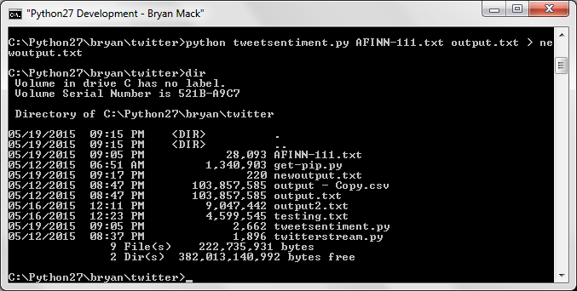

So I now have my sentiment analysis stored in newoutput.txt, it looks like this:

-5 sentiments 99

-4 sentiments 474

-3 sentiments 641

-2 sentiments 1050

-1 sentiments 1549

0 sentiments 0

1 sentiments 1174

2 sentiments 1749

3 sentiments 1376

4 sentiments 276

5 sentiments 2